Pharmacy

Website: https://kwh.9u1.net/Services/Pharmacy.html

請看Pharmacy_1.png 至Pharmacy_4.png
- Page top photo could be actual size with Blur background?
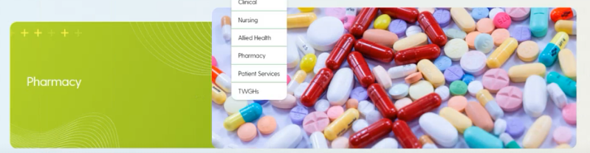
Eg.
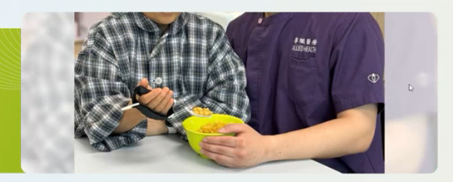

User: Can the vendor make 2 samples for us to choose from – one sample by moving the photo up a little bit to show the top of the ‘R’ and another sample with blur background to show the whole “Rx”?

- How to handle this file?
留意到你們的comments是按【240723 KWH website_Clinical Pharmacy Services (English version)】所列出的次序進行修改
但經檢查後發現, 在【Clinical Pharmacy Services】 Section之中, 原本有的段落【Clinical Ward Pharmacist Service】沒有提及, 請問這一段是要刪掉嗎?
另外發現後落【Pharmacist Oncology Clinic】是原本沒有, 請問是要新增加嗎? 如是, 這段落也是需要右邊配一張圖, 請提供
目前【Ward Clinical Pharmacy Service】及 【Pharmacist Anticoagulant Clinic】段落使用的圖片是同一張, 請為其中一段段落的圖片提供一張新圖

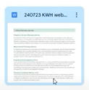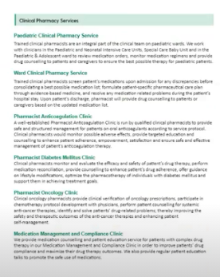

User: Match the content with the keyword in subtitle. Replace the content and rearrange the ordering with the photos.

有關Patient Pamphlets欠缺文件, 請提供
並告知文件是否需要分為3份, 以便在3種不同語言下下載?

已刪掉
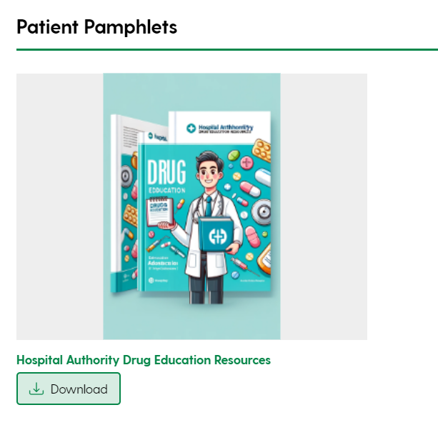
User: This was found in the original version but not provided by Pharmacy, suggest delete the icon and link

User:

不提供graphic design服務, 除非是非常簡單的需求
In addition, can the vendor help with the graphic design for setting the photos in our website?

已修改
There is a typo for the following service hours, should be ‘Saturdays, Sundays and Public Holidays’:
